**Appendix 11 – User Interface design**

**Identifying UI elements**

Table 10 Requirements and supporting UI elements.

|  |  |
| --- | --- |
| **Requirement** | **UI element** |
| SFR1 | Window |
| SFR2 | Text input field or time picker |
| SFR3 | Dropdown list |
| SFR4 | Text input field |
| SFR5 | Button |
| SFR6 | Text display field |
| SFR7 | Notification area |
| SFR8 | Text area |
| SFR9 | Button |
| SFR10 | Notification tab |
| SFR11 | Button |
| SFR12 | Button |
| SFR13 | Notification tab |
| SFR14 | Button |
| SFR15 | Notification tab |
| SFR16 | Notification |
| SFR17 | Button |
| SFR18 | Button |
| SFR19 | Button |
| SFR19.a | Text input area |
| SFR20 | Button |
| SFR20.a.1, SFR20.a.2 | Modal window |
| SFR27 | Notification |
| SFR28 | Text input field |
| SFR29 | Graphics |
| SFR30 | Notification |
| SFR32 | Graphics |
| SFR33 | Text area |
| SFR34 | Window |
| SFR35 | Button |
| SFR35.a | Button |
| SFR36 | Button |
| SFR39 | Button |
| SFR52 | Dropdown list |
| SFR53 | Date picker |
| SFR55 | Window |
| SFR55.a | Alert box |
| SFR56 | Button |

In addition to the elements of the user interface identified in the above table, the UI shall be consistent with the relevant non-functional requirements from Appendix 5. These requirements include:

* *Look-and-feel requirements*
* *Usability and humanity requirements*
* *Security requirements*

Some of the functional requirements were omitted due to decisions made at the system design stage. More elements might be derived from the structural design model if there will be the need for it.

**Wireframing**

First, wireframes will be produced using pen and paper then they will be translated into HTML representation, to help to identify any missing items. Wireframes will be presented to the end users to evaluate if the interface requires any improvements.

The figures below show four tabs of Downtime Management System created using pen and paper.

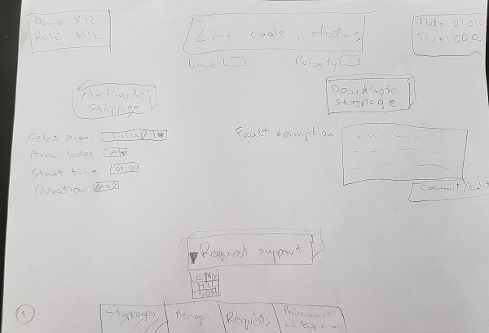

Figure 11 Stoppages page of the pen and paper wireframes for downtime management system.

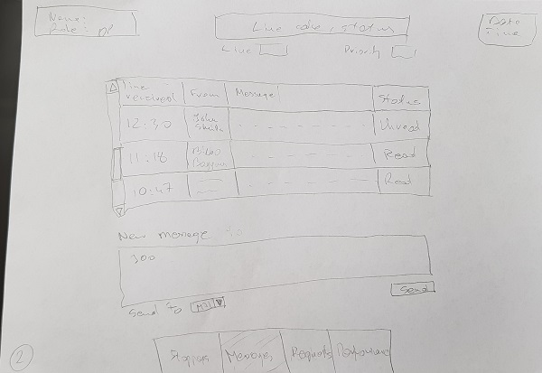

Figure 22 Messages page of the pen and paper wireframes for downtime management system.

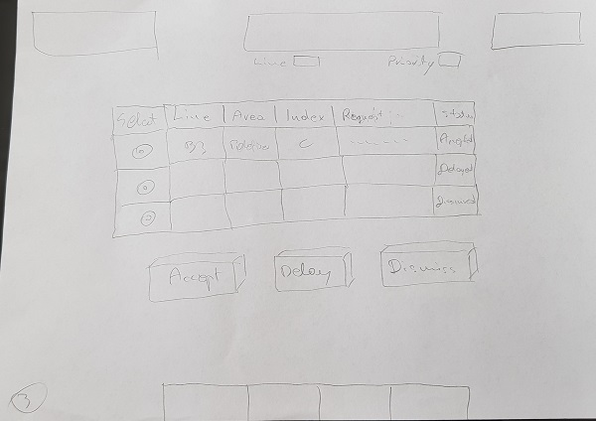

Figure 33 Requests page of the pen and paper wireframes for Downtime Management System.

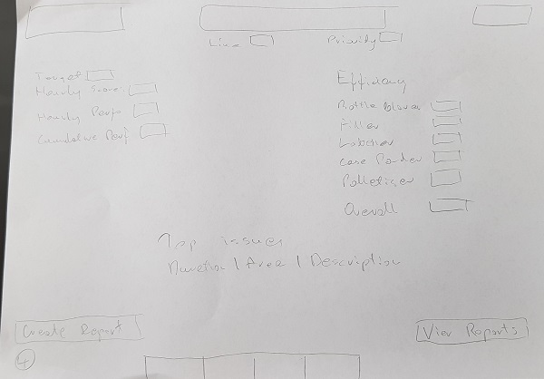

Figure 33 Performance and Efficiency page of the pen and paper wireframes for Downtime Management System.

The draft user interface (wireframes) created with pen and paper was translated into HTML representation. No colours are used and some of the content is missing as it will be produced dynamically in a prototype application. Therefore, wireframes are not an ideal representation of the final system, but they help to identify missing artefacts or additional requirements. They show the possible layout of the components, so the users can evaluate if the user interface will be easy to learn and navigate.

The figures below show the wireframes created with the use of HTML5 and CSS3.

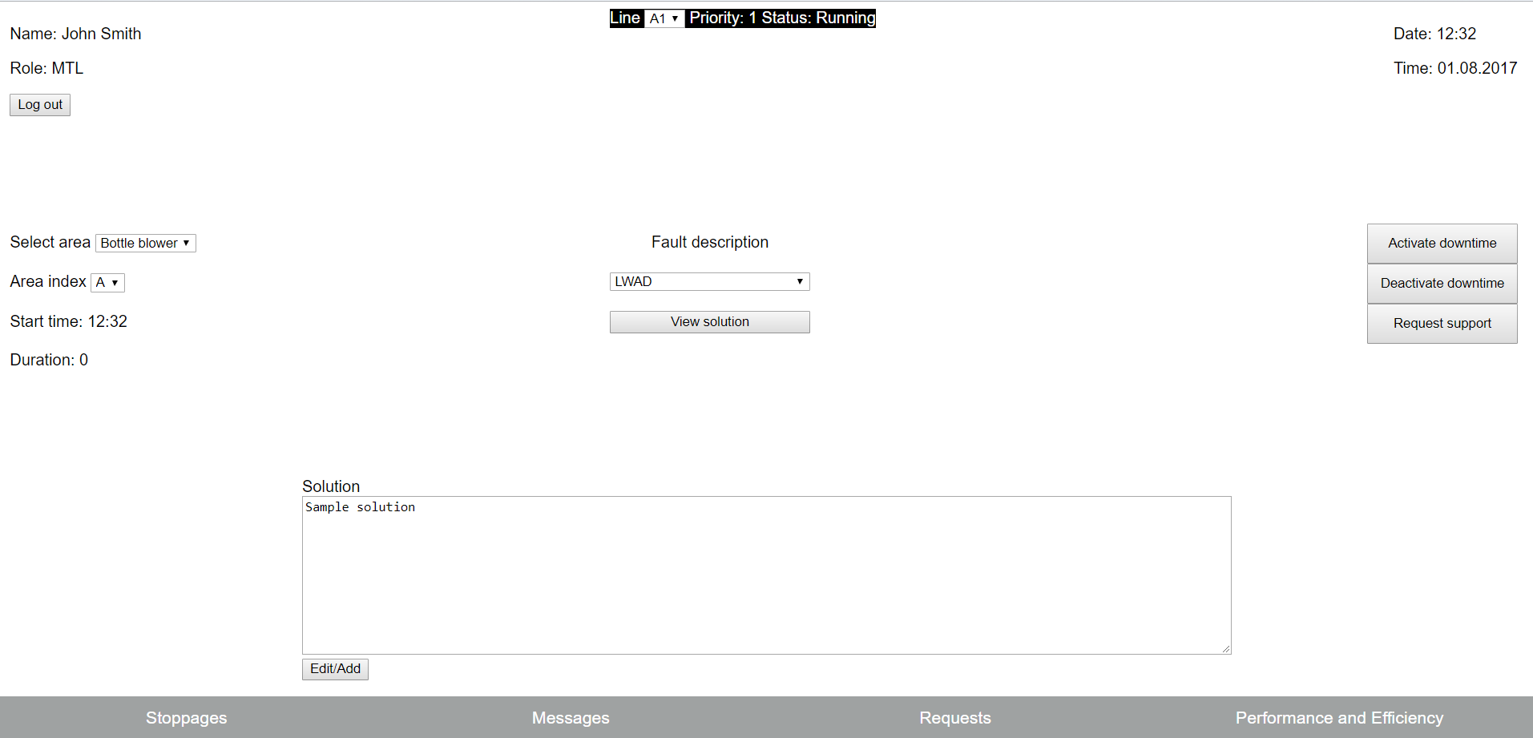

Figure 30 Stoppages page of the wireframes for downtime management system.

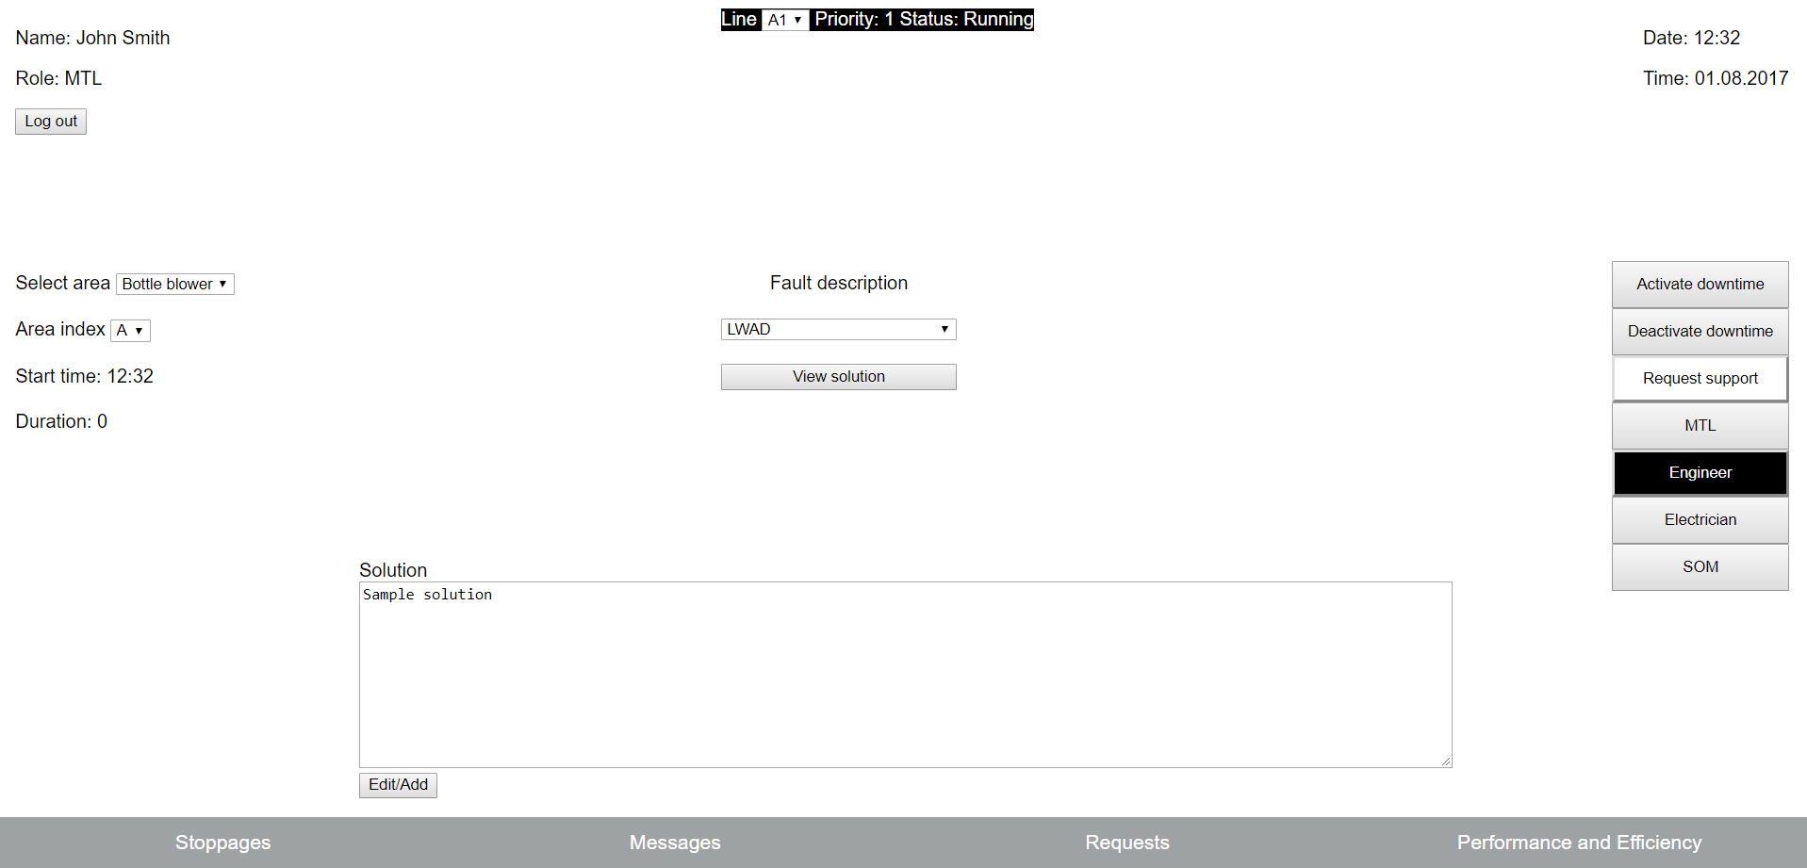

Figure 32 Stoppages page of the wireframes for downtime management system.

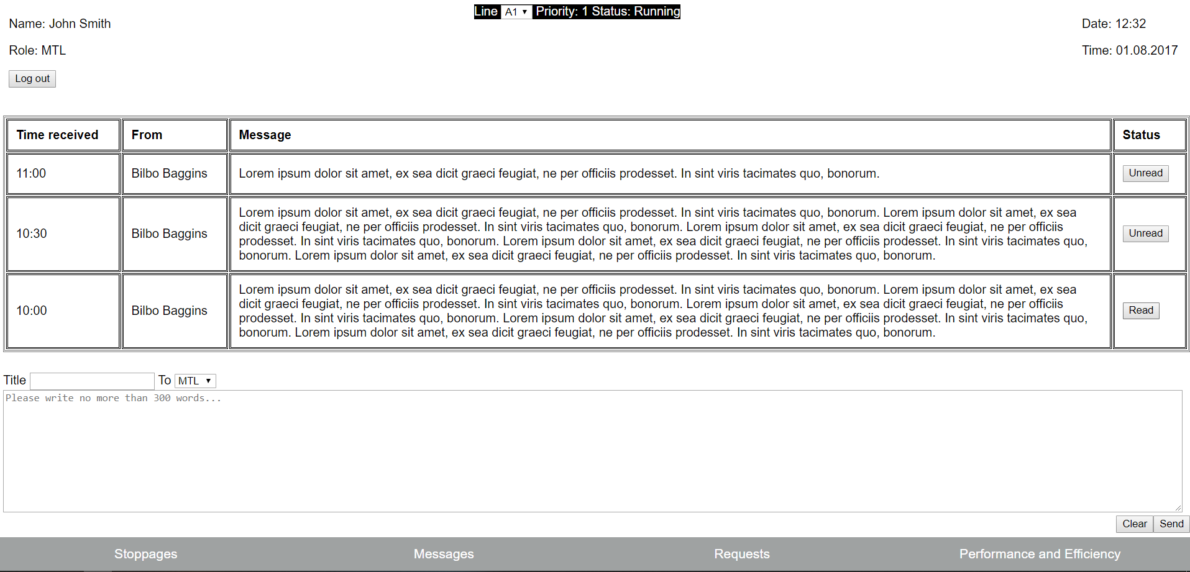

Figure 34 Messages page of the wireframes for downtime management system.

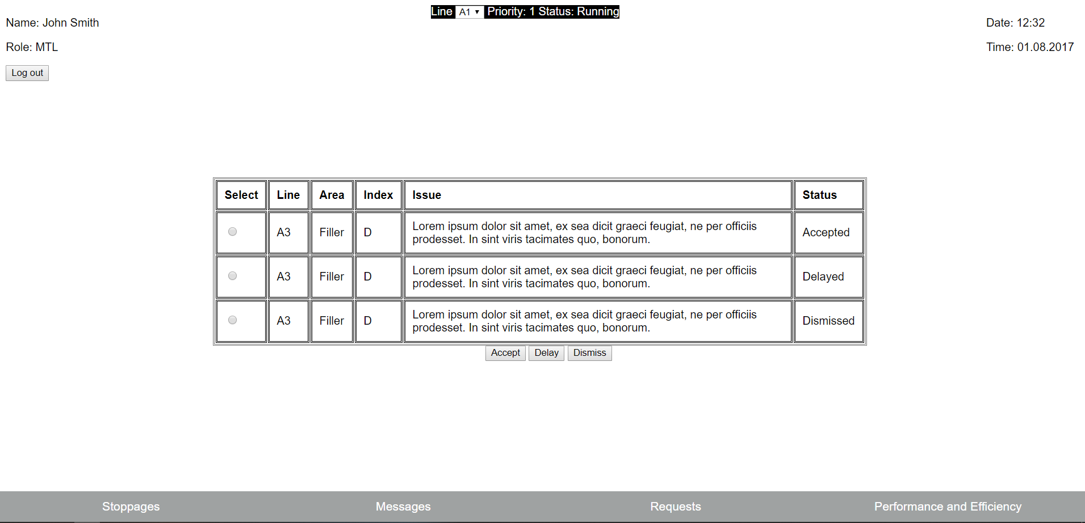

Figure 35 Requests page of the wireframes for downtime management system.

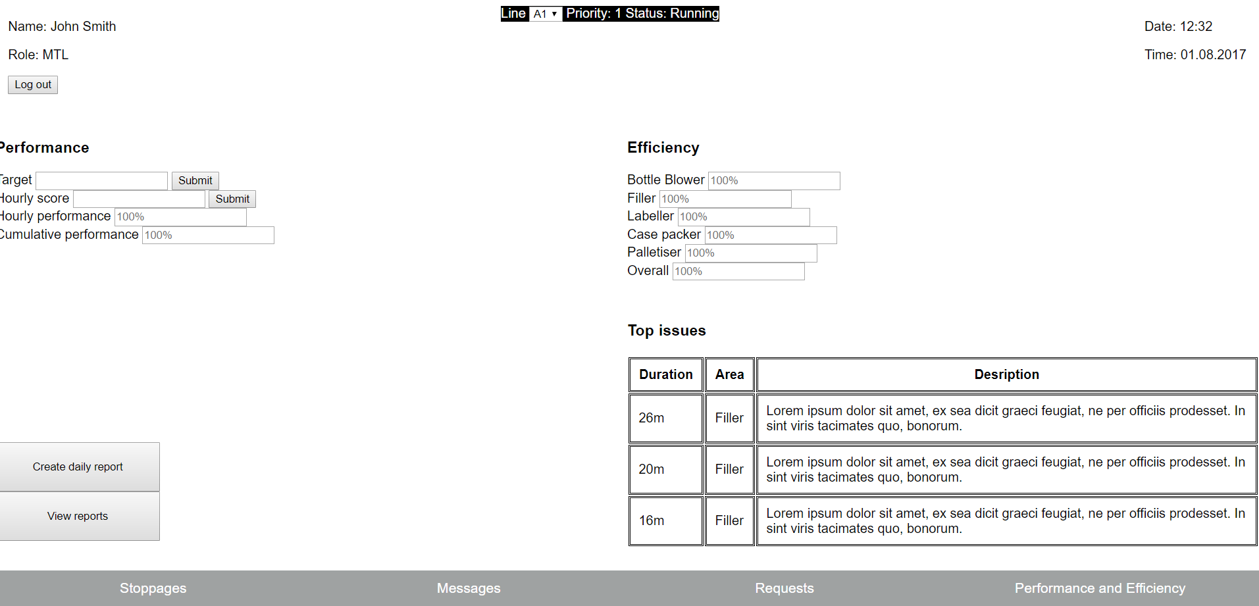

Figure 36 Performance and Efficiency page of the wireframes for downtime management system.

The wireframes include the following files:

stoppage.html:

<!DOCTYPE html>

<html>

<head>

<title>Downtime Management System - Wireframes</title>

<link href="wstyles.css" rel="stylesheet" type="text/css" />

</head>

<body>

<div class="content">

<div class="top">

<div id="left">

<p>Name: John Smith</p>

<p>Role: MTL</p>

<button name="logout">Log out</button>

</div>

<div id="center">

<label>Line</label>

<select>

<option value="a1">A1</option>

<option value="a2">A2</option>

<option value="a3">A3</option>

<option value="a4">A4</option>

</select>

<label>Priority: 1</label>

<label>Status: Running</label>

</div>

<div id="right">

<p>Date: 12:32</p>

<p>Time: 01.08.2017</p>

</div>

</div>

<div class="stoppages">

<div class="sleft">

<div id="area">

<label>Select area</label>

<select>

<option value="bblower">Bottle blower</option>

<option value="filler">Filler</option>

<option value="labeller">Labeller</option>

<option value="cpacker">Case packer</option>

<option value="palletiser">Palletiser</option>

</select><br>

</div>

<div id="index">

<label>Area index</label>

<select>

<option>A</option>

<option>B</option>

<option>C</option>

<option>D</option>

<option>E</option>

</select><br>

</div>

<div id="time">

<label>Start time: 12:32</label><br>

</div>

<div id="dur">

<label>Duration: 0</label>

</div>

</div>

<div class="scenter">

<div id="descr"><label>Fault description</label></div>

<div id="cselect"><select>

<option>LWAD</option>

<option>Cut system fault</option>

<option>Poor label application</option>

<option>Bottle infeed sensor fault</option>

<option>Other...</option>

</select></div>

<div id="cbutton"><button>View solution</button></div>

</div>

<div class="sright">

<button>Activate downtime</button><br>

<button>Deactivate downtime</button><br>

<div class="requests">

<button class="dropreq">Request support</button>

<div class="reqcontent">

<button>MTL</button>

<button>Engineer</button>

<button>Electrician</button>

<button>SOM</button>

</div>

</div>

</div>

</div>

<div class="sol">

<label>Solution</label><br>

<textarea rows="10" maxlength="2000">Sample solution</textarea><br>

<button>Edit/Add</button>

</div>

<div class="navbar">

<a href="stoppage.html" id="p1">Stoppages</a>

<a href="message.html" id="p2">Messages</a>

<a href="requests.html" id="p3">Requests</a>

<a href="performance.html" id="p3">Performance and Efficiency</a>

</div>

</div>

</body>

</html>

message.html:

<!DOCTYPE html>

<html>

<head>

<title>Downtime Management System - Wireframes</title>

<link href="wstyles.css" rel="stylesheet" type="text/css" />

</head>

<body>

<div class="content">

<div class="top">

<div id="left">

<p>Name: John Smith</p>

<p>Role: MTL</p>

<button name="logout">Log out</button>

</div>

<div id="center">

<label>Line</label>

<select>

<option value="a1">A1</option>

<option value="a2">A2</option>

<option value="a3">A3</option>

<option value="a4">A4</option>

</select>

<label>Priority: 1</label>

<label>Status: Running</label>

</div>

<div id="right">

<p>Date: 12:32</p>

<p>Time: 01.08.2017</p>

</div>

</div>

<div class="mtable">

<table>

<tr>

<th>Time received</th>

<th>From</th>

<th>Message</th>

<th>Status</th>

</tr>

<tr>

<td>11:00</td>

<td>Bilbo Baggins</td>

<td class="tscroll">Lorem ipsum dolor sit amet, ex sea dicit graeci feugiat, ne per officiis prodesset. In sint viris tacimates quo, bonorum.</td>

<td>

<button>Unread</button>

</td>

</tr>

<tr>

<td>10:30</td>

<td>Bilbo Baggins</td>

<td class="tscroll">Lorem ipsum dolor sit amet, ex sea dicit graeci feugiat, ne per officiis prodesset. In sint viris tacimates quo, bonorum.

Lorem ipsum dolor sit amet, ex sea dicit graeci feugiat, ne per officiis prodesset. In sint viris tacimates quo, bonorum.

Lorem ipsum dolor sit amet, ex sea dicit graeci feugiat, ne per officiis prodesset. In sint viris tacimates quo, bonorum.

Lorem ipsum dolor sit amet, ex sea dicit graeci feugiat, ne per officiis prodesset. In sint viris tacimates quo, bonorum.

Lorem ipsum dolor sit amet, ex sea dicit graeci feugiat, ne per officiis prodesset. In sint viris tacimates quo, bonorum.</td>

<td>

<button>Unread</button>

</td>

</tr>

<tr>

<td>10:00</td>

<td>Bilbo Baggins</td>

<td class="tscroll">Lorem ipsum dolor sit amet, ex sea dicit graeci feugiat, ne per officiis prodesset. In sint viris tacimates quo, bonorum.

Lorem ipsum dolor sit amet, ex sea dicit graeci feugiat, ne per officiis prodesset. In sint viris tacimates quo, bonorum.

Lorem ipsum dolor sit amet, ex sea dicit graeci feugiat, ne per officiis prodesset. In sint viris tacimates quo, bonorum.

Lorem ipsum dolor sit amet, ex sea dicit graeci feugiat, ne per officiis prodesset. In sint viris tacimates quo, bonorum.

Lorem ipsum dolor sit amet, ex sea dicit graeci feugiat, ne per officiis prodesset. In sint viris tacimates quo, bonorum.</td>

<td>

<button>Read</button>

</td>

</tr>

</table>

</div>

<div class="mform">

<form>

<label for="title">Title</label>

<input type="text" id="titleField" name="title"/>

<label>To</label>

<select>

<option>MTL</option>

<option>ETL</option>

<option>SOM</option>

</select>

<textarea rows="10" cols="200" maxlength="2000" placeholder="Please write no more than 300 words..."></textarea><br/>

<input id="btns" type="submit" value="Send" />

<input id="btnc" type="reset" value="Clear" />

</form>

</div>

<div class="navbar">

<a href="stoppage.html">Stoppages</a>

<a href="message.html">Messages</a>

<a href="requests.html">Requests</a>

<a href="performance.html">Performance and Efficiency</a>

</div>

</div>

</body>

</html>

requests.html:

<!DOCTYPE html>

<html>

<head>

<title>Downtime Management System - Wireframes</title>

<link href="wstyles.css" rel="stylesheet" type="text/css" />

</head>

<body>

<div class="content">

<div class="top">

<div id="left">

<p>Name: John Smith</p>

<p>Role: MTL</p>

<button name="logout">Log out</button>

</div>

<div id="center">

<label>Line</label>

<select>

<option value="a1">A1</option>

<option value="a2">A2</option>

<option value="a3">A3</option>

<option value="a4">A4</option>

</select>

<label>Priority: 1</label>

<label>Status: Running</label>

</div>

<div id="right">

<p>Date: 12:32</p>

<p>Time: 01.08.2017</p>

</div>

</div>

<div class="reqTab">

<table>

<tr>

<th>Select</th>

<th>Line</th>

<th>Area</th>

<th>Index</th>

<th>Issue</th>

<th>Status</th>

</tr>

<tr>

<td>

<input type="radio" name="select">

</td>

<td>A3</td>

<td>Filler</td>

<td>D</td>

<td>Lorem ipsum dolor sit amet, ex sea dicit graeci feugiat, ne per officiis prodesset. In sint viris tacimates quo, bonorum.</td>

<td>Accepted</td>

</tr>

<tr>

<td>

<input type="radio" name="select">

</td>

<td>A3</td>

<td>Filler</td>

<td>D</td>

<td>Lorem ipsum dolor sit amet, ex sea dicit graeci feugiat, ne per officiis prodesset. In sint viris tacimates quo, bonorum.</td>

<td>Delayed</td>

</tr>

<tr>

<td>

<input type="radio" name="select">

</td>

<td>A3</td>

<td>Filler</td>

<td>D</td>

<td>Lorem ipsum dolor sit amet, ex sea dicit graeci feugiat, ne per officiis prodesset. In sint viris tacimates quo, bonorum.</td>

<td>Dismissed</td>

</tr>

</table>

<div class="reqButtons">

<button id="acc">Accept</button>

<button id="del">Delay</button>

<button id="dis">Dismiss</button>

</div>

</div>

<div class="navbar">

<a href="stoppage.html">Stoppages</a>

<a href="message.html">Messages</a>

<a href="requests.html">Requests</a>

<a href="performance.html">Performance and Efficiency</a>

</div>

</div>

</body>

</html>

performance.html:

<!DOCTYPE html>

<html>

<head>

<title>Downtime Management System - Wireframes</title>

<link href="wstyles.css" rel="stylesheet" type="text/css" />

</head>

<body>

<div class="content">

<div class="top">

<div id="left">

<p>Name: John Smith</p>

<p>Role: MTL</p>

<button name="logout">Log out</button>

</div>

<div id="center">

<label>Line</label>

<select>

<option value="a1">A1</option>

<option value="a2">A2</option>

<option value="a3">A3</option>

<option value="a4">A4</option>

</select>

<label>Priority: 1</label>

<label>Status: Running</label>

</div>

<div id="right">

<p>Date: 12:32</p>

<p>Time: 01.08.2017</p>

</div>

</div>

<div class="perfLeft">

<h3>Performance</h3>

<label>Target</label>

<input type="text">

<button>Submit</button><br>

<label>Hourly score</label>

<input type="text">

<button>Submit</button><br>

<label>Hourly performance</label>

<input type="text" readonly="readonly" placeholder="100%"><br>

<label>Cumulative performance</label>

<input type="text" readonly="readonly" placeholder="100%"><br>

<div class="repButtons">

<button>Create daily report</button><br>

<button>View reports</button>

</div>

</div>

<div class="perfRight">

<h3>Efficiency</h3>

<label>Bottle Blower</label>

<input type="text" readonly="readonly" placeholder="100%"><br>

<label>Filler</label>

<input type="text" readonly="readonly" placeholder="100%"><br>

<label>Labeller</label>

<input type="text" readonly="readonly" placeholder="100%"><br>

<label>Case packer</label>

<input type="text" readonly="readonly" placeholder="100%"><br>

<label>Palletiser</label>

<input type="text" readonly="readonly" placeholder="100%"><br>

<label>Overall</label>

<input type="text" readonly="readonly" placeholder="100%"><br>

<div id="tTitle">

<h3>Top issues</h3>

</div>

<table class="topIssues">

<tr>

<th>Duration</th>

<th>Area</th>

<th>Desription</th>

</tr>

<tr>

<td>26m</td>

<td>Filler</td>

<td>Lorem ipsum dolor sit amet, ex sea dicit graeci feugiat, ne per officiis prodesset. In sint viris tacimates quo, bonorum.</td>

</tr>

<tr>

<td>20m</td>

<td>Filler</td>

<td>Lorem ipsum dolor sit amet, ex sea dicit graeci feugiat, ne per officiis prodesset. In sint viris tacimates quo, bonorum.</td>

</tr>

<tr>

<td>16m</td>

<td>Filler</td>

<td>Lorem ipsum dolor sit amet, ex sea dicit graeci feugiat, ne per officiis prodesset. In sint viris tacimates quo, bonorum.</td>

</tr>

</table>

</div>

<div class="navbar">

<a href="stoppage.html">Stoppages</a>

<a href="message.html">Messages</a>

<a href="requests.html">Requests</a>

<a href="performance.html">Performance and Efficiency</a>

</div>

</div>

</body>

</html>

CSS file wstyles.css:

body{

font-family: sans-serif;

}

.top{

text-align: left;

height: 10%;

position: fixed;

top: 1%;

}

#left{

position: fixed;

left: 1%;

}

#center{

position: fixed;

left: 40%;

text-align: center;

background-color: black;

color: white;

}

#right{

position: fixed;

right: 1%;

}

.stoppages{

position: fixed;

top: 30%;

}

.sleft{

position: fixed;

left: 1%;

}

#area{

padding: 10px 0 10px 0;

}

#index{

padding: 10px 0 10px 0;

}

#time{

padding: 10px 0 10px 0;

}

#dur{

padding: 10px 0 10px 0;

}

.scenter{

position: fixed;

left: 40%;

text-align: center;

background-color: black;

color: white;

}

.scenter select{

width: 200px;

}

.scenter button{

width: 200px;

}

#descr{

padding: 10px 0 10px 0;

background-color: white;

color: black;

}

#cselect{

padding: 10px 0 10px 0;

background-color: white;

color: black;

}

#cbutton{

padding: 10px 0 10px 0;

background-color: white;

color: black;

}

.sright{

position: fixed;

right: 1%;

}

.sright button{

width: 150px;

padding: 10px;

}

.sol{

position: fixed;

bottom: 60px;

left: 20%;

right: 20%;

}

.sol textarea{

width: 100%;

text-align: left;

}

.requests{

position: relative;

display: inline-block;

}

.reqcontent{

display: none;

position: absolute;

z-index: 1;

}

.reqcontent button:hover{background-color: black; color: white;}

.requests:hover .reqcontent{display: block;}

.requests:hover .dropreq{background-color: white;}

.mtable{

position: fixed;

top: 150px;

}

.mtable table{

text-align: left;

border-style: double;

table-layout: fixed;

}

.mtable th{

padding: 10px;

border-style: double;

}

.mtable td{

padding: 10px;

border-style: double;

}

.tscroll{

width: 75%;

height: 30px;

overflow: auto;

}

.mform{

position: absolute;

bottom: 50px;

}

.mform textarea{width: 99%;}

#btns{float: right;}

#btnc{float: right;}

.reqTab{

position: fixed;

top: 250px;

left: 20%;

right: 20%;

}

.reqTab table{

text-align: left;

border-style: double;

table-layout: fixed;

}

.reqTab th{

padding: 10px;

border-style: double;

}

.reqTab td{

padding: 10px;

border-style: double;

}

.reqButtons{position: fixed; left: 45%;}

.perfLeft{

position: fixed;

top: 150px;

width: 50%;

left: 0;

}

.repButtons{

margin-top: 100px;

position: fixed;

bottom: 80px;

}

.repButtons button{

width: 200px;

height: 60px;

padding: 10px;

}

.perfRight{

position: fixed;

top: 150px;

width: 50%;

right: 0;

}

.topIssues{

margin-top: 20px;

}

.topIssues td, th{

padding: 10px;

border-style: double;

}

#tTitle h3{margin-top: 50px;}

.navbar{

overflow: auto;

background: #9FA2A2;

position: fixed;

bottom: 0;

width: 100%;

left: 0%;

right: 0%;

list-style: none;

}

.navbar a {

float: left;

padding: 12px;

color: white;

text-decoration: none;

font-size: 17px;

width: 23.42%;

text-align: center;

}

.navbar a:hover{

background: #f1f1f1;

color: black;

}

The code for the above files is quite messy and not commented out because there is no need for reproducing this code in any further development. The next step was to present the wireframes to the users, so they could evaluate them and share an opinion about the functionalities of the draft UI.

The users identified the following problems:

* The layout of the ‘Stoppages’ and ‘Performance and Efficiency’ tabs is cluttered.

Suggested solution: Where possible organise content into tables (similarly to original paperwork for stoppages and performance and efficiency).

* The ‘Requests’ tab contains too much empty space.

Suggested solution: If possible merge ‘Requests’ and ‘Messages’ tabs.

* No planned downtime has been considered.

Suggested solution: Include planned downtime as it will affect calculations of performance and efficiency.

* The system shall have an ability to set up line parameters such as targets, priority, availability, product name or line leader.

Suggested solution: Create an additional tab e.g. ‘Line setup’ available to MTL’s.

Rather than producing new wireframes, the above problems will be resolved during the development of the prototype.